BLDC Motherboard pins definition (CN94)
Pin No. | Function | Description
1 | GK | If over current or low voltage protection is triggered in gate driver, this pin gives the following:  V_{GK}  3.3V Gate driver work in normal  0V Gate driver in protection
2 | PWMWH | High-side IGBT voltage level for W phase:  V_{PWMWH}  >2.4V IGBT on  <0.7V IGBT off
3 | PWMWL | Low-side IGBT voltage level for W phase:  V_{PWMWL}  >2.4V IGBT on  <0.7V IGBT off
4 | PWMVH | High-side IGBT voltage level for V phase:  V_{PWMVH}  >2.4V IGBT on  <0.7V IGBT off
5 | PWMVL | Low-side IGBT voltage level for V phase:  V_{PWMVL}  >2.4V IGBT on  <0.7V IGBT off
6 | PWMUH | High-side IGBT voltage level for U phase:  V_{PWMUH}  >2.4V IGBT on  <0.7V IGBT off
7 | PWMUL | Low-side IGBT voltage level for U phase:  V_{PWMUL}  >2.4V IGBT on  <0.7V IGBT off
8 | RSH+ | - DC Bus Current feedback detection，Rshunt =0.1Ω  Feedback signal level V_{RSH+} = 0.1*I_{DCBUS}  For example:  RSH+ Voltage V_{RSH+} DC BUS current I_{DCBUS}  0.2V 2A  - If V_{RSH+} > 0.88V, the gate driver over current protection (OCP) will be triggered and all PWM pins turn off
9 | HV- | HV- ground pin
10 | +5V | +5V output
11 | +3.3 | +3.3V output
12 | VTH | IGBT temperature detection pin using a thermistor R_{RTH4} placed near Q901.  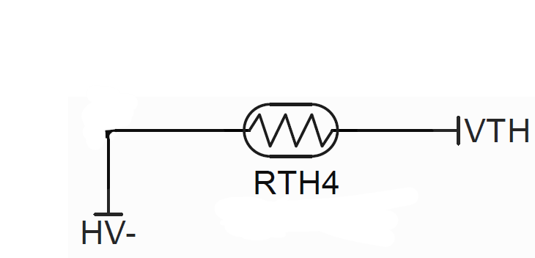  The relation between R_{RTH4} resistance and temperature is as follow：  Temperature ℃ 0 25 50 100 110 120  Resistance Ω 27k 10k 4.13k 0.96k 0.75k 0.60k  RTH4 type: TSM2A103F34D1R (Thinking Electronic)
13 | BRAKE | Shunt braking resistor trigger level.  This function is recommended when DC Bus> 400V.  An external regenerative resistor (300Ω recommended) on CN100 of motherboard is required.  V_{BRAKE}  >3V Regenerative resistor off  <0.5V Regenerative resistor on
14 | Eempty pin
15 | HV1 | 380V DC Bus voltage detection.  R948 (665kΩ) on motherboard together with another resistor on daughterboard are used as voltage divider for DC Bus (HV+) detection.  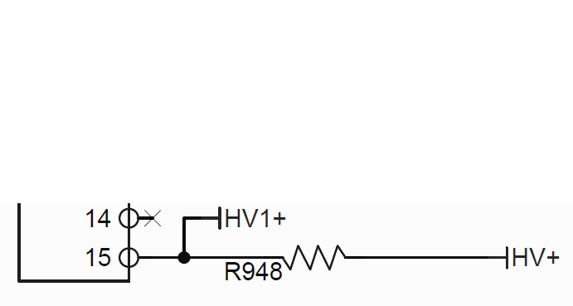

Control daughter board pins definition (CN93)
Pin No. | Function | Description
1 | +5V | +5VDC output pin; Max. current 0.2A
2 | Hall detection 1 | Digital Hall IC detection input 1 pin (No needed in case default MCU firmware is used)
3 | Hall detection 3 | Digital Hall IC detection input 3 pin (No needed in case default MCU firmware is used)
4 | Hall detection 2 | Digital Hall IC detection input 2 pin (No needed in case default MCU firmware is used)
5 | GND | Ground pin for Hall IC, speed control and Start/stop
6 | Rotating speed | Input pin for speed control  Forward rotation (0~100%): 5~9.6V  Reverse rotation (0~100%): 5~0.4V
7 | Start/Stop | Input pin for motor start or stop  Start: +5V  Stop: open
8 | Empty pin
9 | TXD | RS-232 TX signal
10 | RXD | RS-232 RX signal

